Week 5 Literature Reviews

Inductive Coding

Walker, R., Clary, R. M., & Wissehr, C. (2017). Embedding sustainability instruction across
content areas: Best classroom practices from informal environmental education. Journal of Geoscience Education, 65(2), 185-193.

https://www-tandfonline-com.libproxy.furman.edu/doi/full/10.5408/16-167.1

This article uses grounded theory to code qualitative information from teachers and students. Throughout interactions between students, teachers, and an environmental residency camp center, the researchers identified the characteristics of effective environmental education. Students identified developing curiosity and a sense of discovery as the most meaningful in environmental education. Most student-identified meaningful experiences aligned with planned objectives of the environmental resident camp, but some emerged through the data collection and reflections.
The camp shifts values from recycling to social responsibility and sustainable development. Immediately after the residential program, students were asked to complete an open-ended questionnaire and reflection about meaningful things they learned, what they were curious about, and what they were confused about. The teachers were asked to give their perceptions of the camp’s objectives and which ones they valued the most, like developing life skills during the experience. One researcher coded these responses based on emerging themes. The majority of the coding scheme reflected the camp’s overarching goals and established objectives (teamwork, wilderness navigation, ecosystems, physical exercise, friends), but a few emerged that did not explicitly align with any lesson plans. These were connection to nature and self-awareness, which were components of the experience, but were not related to one specific lesson.
The implicit aspects of outdoor learning are often overlooked, but teachers indicated that they are just as important as what is in the lesson plan. An outcome of this study was that teachers paid more attention to how they deliver content, to go beyond the traditional views of instruction to include implicit embedded instruction and experiential learning.
This is relevant to my thesis because I am doing inductive coding, but also have general themes that I have established in my project – curriculum, materials, and public arts sphere. These general themes are similar to the camp’s overarching goals in learning outcomes. However, some themes may emerge from my data do not fit into those three parent codes. The implicit aspects of sustainability are also overlooked with some teachers I have interviewed, and as a result of the interview, they are giving it more thought.

Sustainability in the Arts

What does sustainability mean for the art world? (2019, September 11). Invaluable. Retrieved
June 19th, 2020, from https://www.invaluable.com/blog/sustainability-and-art/

Artists who make sustainable art hope to not only change how their work is made, but to inspire social and cultural change as well. The most resonant SDG for artists is goal twelve, responsible consumption and production (which is the SDG I based my Millennium Fellowship application off of). This goal requires companies and artists to work towards environmentally conscious practices and increase the use of natural materials within products and art.
Sustainable art is intended to provide perspective on the world in its current state, suggest potential solutions, and raise awareness for issues that artists are passionate about. Sustainable art inspires social and environmental consciousness. For example, John Sabraw’s Toxic Sludge paintings and Paulo Grangeon’s 1,600 Pandas bring awareness to human impacts on the environment and loss of biodiversity. In addition, the Japanese art of Kintsugi is the act of repairing broken pottery with gold, celebrating imperfection, upcycling, and discouraging waste. Also, the Japanese art of Furoshiki is a technique of fabric folding as a way to protect and wrap gifts, creating reusable packaging.
In regard to schools, the Fashion Institute of Technology installed a garden for creating vegetable-based dyes as well as a school-wide composting system for leftover cotton and other fibers.

There are many different types of sustainable art:
- Ecological Art- functional art that focuses on restoration and activism, also includes ethics, social responsibility, and justice. Includes improving something already created to transform a community, like restoring an art studio for local artists to work together for the community.
- Land Art/Earth Art/Earth Works/Eco Art- Land art uses materials derived from nature to create artwork woven into the fabric of the land, emphasizing the beauty of nature. The environment is part of the work.
- Renewable Energy Sculpture- bring renewable energy in a unique and artistic way, sculptures that use solar, wind, hydroelectric, tidal, and geothermal resources to create movement, energy, and power. The artists remind viewers of nature’s true beauty and power.
- Upcycling- art created from material previously deemed unusable, unwanted, or broken
- Eco Design- taking the environment into consideration when building or creating
- Bio Art- working with live bacteria or living organisms
- Closed-loop fashion- clothes transformed back to original form
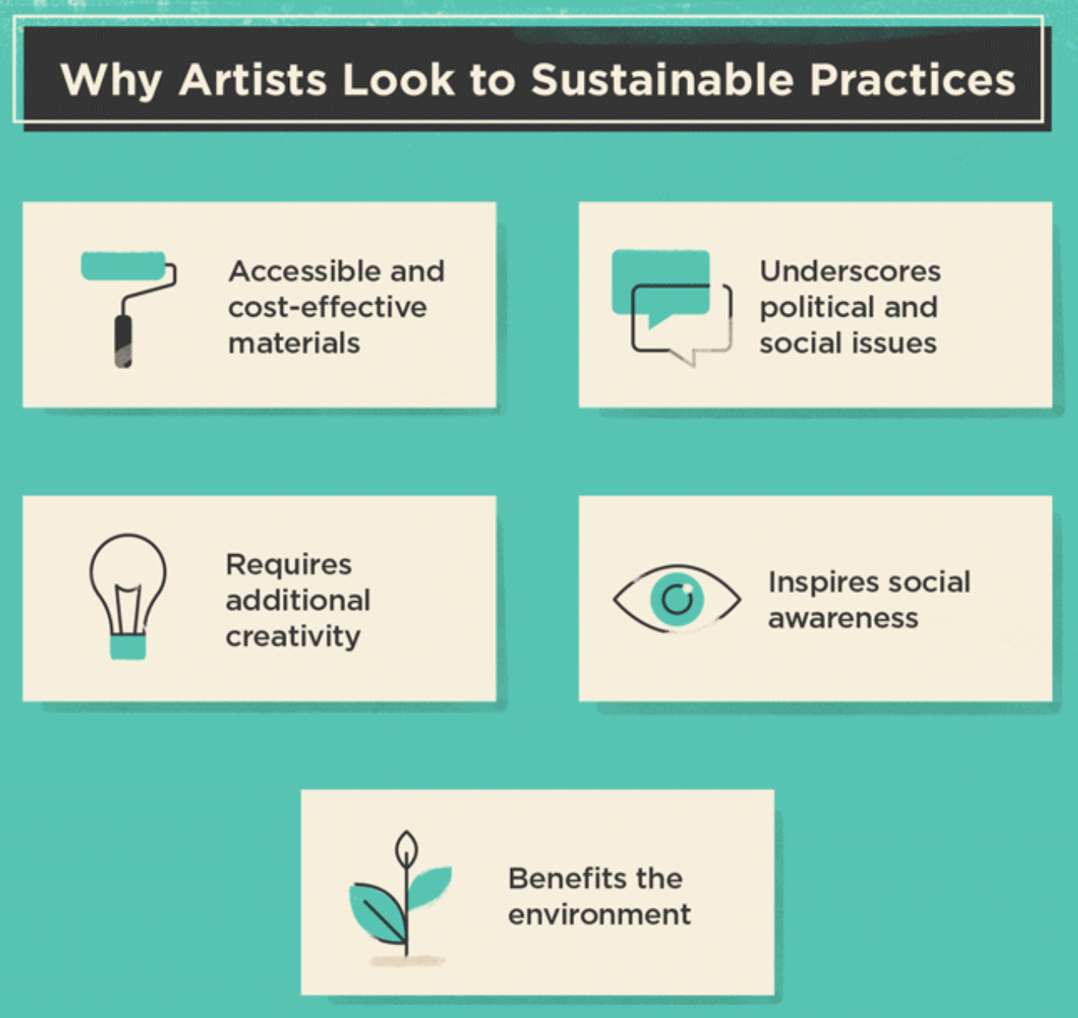

“Sustainable art blurs the line between science and design for the benefit of both the audience and the environment.” The figure above gives reasons for why artists make sustainable art, and what sustainability can do for art. Previously, I have looked at articles about what art can do for sustainability, but this article shows that they are both benefitting and enhancing the other when combined. This article and figure relate to my first research question of the role of sustainability in art education and gives me more clarity about what types of projects teachers are doing and why, and how they are using materials, reflecting my second research question. The article also gives context for how art and sustainability are combined throughout the world, and initiatives in a school. It also provides good context for the next literature review, which discusses art projects for ESD.

ESD Class Project Examples
Özsoy, V. (2016). Arts and design Education for Sustainable Development. Global Journal on
Humanities & Social Sciences, 43(3), 487-497.

This article focuses on the United Nations’ ESD action through UNESCO in 2004. ESD educates to provide students the knowledge, skills, attitudes and values necessary to shape a sustainable future, by including key sustainable development issues into education. This article focuses on the competencies ESD promotes – critical thinking, imagining future scenarios, and making decisions in a collaborative way, changing the way education is often practiced today. The Turkish Environment Education Foundation (TÜRÇEV) is an NGO that started the Eco-schools Program in Turkey to carry out ESD in schools, and provides a Green Flag award, similar to Green Ribbon in the U.S. This author looks at how ESD has taken place in schools in Turkey through the arts.
Sustainability education teaches students how to solve and understand problems. It emphasizes the discovery process and makes students think creatively about alternative solutions and possibilities. Art education has a multi-directional content and flexibility for sustainable development ideals. For example, aesthetic sensitivity and critical thinking which are in the nature of art and design subjects, help students strengthen environmental sensitivities and sustainability competencies. Sustainability in art lessons help clarify and bring light to the fact that sustainable ecosysetms are important for a sustainable and quality life. The arts teach students that questions/problems can have more than one answer, small differences have large effects, and celebrates multiple perspectives and diversity. Here are some applications in schools:

- Time Capsule: preserve something that should not be lost in the future. They created anything with that guideline and put it under a glass dome/jar, and attached a small note explaining why (animal, plant, memory). They were displayed to the public, and students felt that they had an effect outside of the classroom. Outcome: self-evaluation and values thinking.
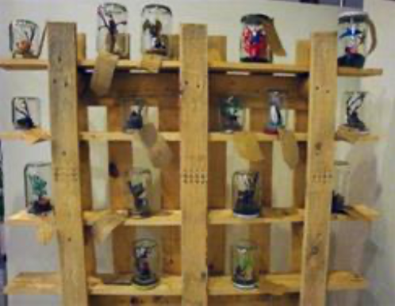
- Café Heimdal: micro urban renewal project, public art that examined ideas of local residents, bringing the community together with the students.
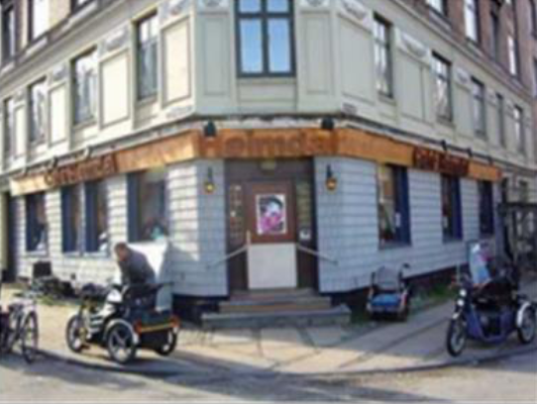
- Lessons Learned from the Landscape: started with journaling, observing, and appreciating the landscape. Goals: create art out of natural materials, develop a sense of place, and become aware of how you are embedded in the ecosystem. “going beyond the classroom, being situated in the landscape, observing and interpreting nature through art forms, and creating authentic learning opportunities in context promotes appreciation for the environment.”

These projects and this article relate to all three of my research questions. The projects exemplify how teachers across the country have embedded sustainability into their curriculum, and how another country has efforts similar to our Green Ribbon certification. The project examples show how teachers have used different materials to create Earth Works and Ecological Art explained in the reading before this one. There is also the aspect of schools collaborating with the larger community to create public art. One teacher I interviewed talked about creating Earth Works with students by sorting and photographing leaves outside, while also teaching them about the local ecosystem.

