Week 4 Literature Reviews

Education, Arts and Sustainability: Emerging Practice for a Changing World

Arnold, A., Emery, S., Hill, A., & Hunter, M. (2018). Education, arts and sustainability:
Emerging practice for a changing world. Springer.
This book talks about how conceptual principles and criteria for sustainability can be transformed into practice. Tools and instruments for implementation of sustainability theories and ideas must be present for students to engage with the jargon of sustainability. Interdependence, integration, and participation are the three most important facets of how sustainability might be envisioned and implemented in educational practice (Arnold et al., 2018, p. 17). These three concepts fit with my three research questions: I am looking at the interdependence of art and sustainability in education, the integration of sustainability in the way art teachers use materials, and the extent to which schools participate in the larger Greenville arts community.
This book gives more clarity on background information about emerging global topics I have touched on before: Education for Sustainability (EfS) and Education for Sustainable Development (ESD). The UN’s organization, United Nations Educational, Scientific, and Cultural Organization (UNESCO), states ESD’s goals are to help “every human being to acquire the knowledge, skills, attitudes and values necessary to shape a sustainable future” (UNESCO 2015). This is obtained through holistic lifelong learning to transform society. ESD shaped EfS, prominent in Australia and New Zealand, which focuses on systemic change by providing awareness and information, as well as building capacity to implement solutions. The Department of the Environment Water Heritage and the Arts (DEWHA, 2009) in Australia provides 7 principles (literature reviews week 2) for EfS, which are very similar to the 5 sustainability competencies, and align with goals of ESD. These common values within sustainability theories provide a framework for looking at how art and sustainability are both integrated into education.
A sustainability-focused education across all subjects can help lift an “epistemological fog” that has caused the government and individuals to fail to recognize that education plays a vital role in addressing social and environmental unsustainability in a time of inequality, oppression, and degradation (p. 21). The arts and sustainability are both taught through teaching independent and interdependent thinking, and integration in an organic way (pp. 22-23). This approach to a “rhizomatic integration of the arts that values complicated and disruptive possibilities that enliven the imagination toward more socially just ways of living and learning (Wiebe et al. 2007, p. 263)” is an arts–sustainability pedagogy (p. 23) in which students engage in collaborative inquiry through the arts and guided problem solving, which are core values of sustainability (pp. 27-30). Because art and sustainability are open ended and have an interdisciplinarity quality, they can directly lead to the 5 sustainability competencies.
This book combines art and sustainability, provides a framework for my research questions and for how sustainability enhances art, and gives case studies based on the 5 competencies in an art focused setting. I can look for projects and goals that are in these case studies as I continue with my teacher interviews. Here are 3 chapters that I found to be the most relevant to my research questions:
Chapter 5: The Story of a SmartPhone (Systems Thinking)
Arnold, A., Emery, S., Hill, A., & Hunter, M. (2018). The story of a SmartPhone (systems
thinking). In SpringerBriefs in Education editorial review (Eds.), Education, arts and sustainability: Emerging practice for a changing world (pp. 61-73). Springer.

Systems thinking helps people understand relationships in the world, and requires inquiry, curiosity, problem-solving, perspective, observing patterns, and making connections. The following case study explores how systems thinking pedagogies within creative arts pedagogies provide students opportunities to develop these skills. For example, one major tenet in art is making the work process available, like through keeping a sketchbook and reflecting on your process to enhance your next project and grow. Systems thinking is inherent in the process of creating, presenting, responding, and transforming in art.
The case study takes place at East Launceston Primary School (ELPS) in Australia. A teacher showed her classroom the video The Story of Stuff with Annie Leonard, and the students broke into 5 groups and had to represent the story of extraction, production, distribution, consumption, and disposal through different art forms. One group made large cardboard set pieces and props like trucks to show Smartphone material distribution and narrated their piece after doing research. The elementary school students liked how the art they made had a clear message, and their performance/presentation confidence improved. The students had a sense of the global impact of consumerism, improved collaboration, and contemplated individual impacts on the world. The teacher said afterward, “Engaging in the arts and sustainability together provoked a deeper understanding of the effects we are having, than the more traditional modes of teaching.”
This form of teaching was guided project-based and student-led inquiry guided by a systems framework - the video. They learned and answered questions by focusing on the process. They had to research and represent a global production system, as well as negotiate how certain materials would produce the best outcome for the presentation. This case study answers my first research question by showing the current importance of the role of sustainability in art education for students.

Chapter 6: The Festival of Wood (Envisioning Better Futures)

Arnold, A., Emery, S., Hill, A., & Hunter, M. (2018). The festival of wood (envisioning better
futures). In SpringerBriefs in Education editorial review (Eds.), Education, arts and sustainability: Emerging practice for a changing world (pp. 75-81). Springer.

Futures thinking requires imagining and caring for life beyond your lifespan but taking action now to work towards a more sustainable future and intergenerational equity (shared resources within generations). Envisioning is about an emergent and creative process, rather than a linear planned out goal. This is achieved through collective visioning and process-based learning that builds capacity and critical thinking. The arts celebrate exploring new meaning, new ideas, and new futures, symbolically and socially. This process of creating a better future, as well as creating steps necessary to get there, involves teachers and students engaging with difficult and incomplete knowledge in a multilayered process of strategic thinking, collaboration, and systems thinking, mirroring creative artmaking itself.
This case study takes place in Tasmania, where the region’s connections to forests are recognized by The Festival of Wood. The Lilydale District School’s (K-10) visual art teacher led the school’s participation in the festival. The students partnered with artists and community members to visually map their community, create public art on the town’s lampposts, and collaborate to upcycle and install old books into the Tree of Knowledge, symbolizing their community’s changing resource base. This case study exemplifies the visionary capacities of arts–sustainability pedagogy.
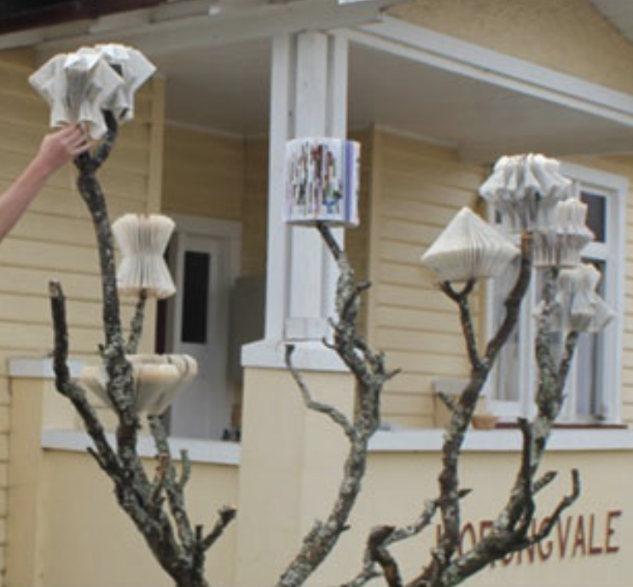
For the Festival of Wood, this art teacher paired with a community artist in residence to engage students in creating the paper sculptures and ask questions about the timber industry. Students also created their own visual representations of places in the town that are significant to them, and they made a collective map of the town. This giant map of the town based off of kids’ perceptions of it, sparked conversations about what the future of the town is going to look like. The art teacher considered, “What new narratives might begin if young people’s own images of the town were displayed as public art on the town’s timber lamp-posts?” The students investigated region-wide problems and visually represented their thoughts on the future of the logging industry in an image-based conversation about what was significant to them about the past, present and future of the town.
This case study exemplified and made me think about how for my thesis I am taking two subject, science and art, that are usually seen as dichotomous and making them interdependent. This case study exemplifies all three of my research questions: the role of sustainability in art curriculum was shown with the goal of futures thinking in class projects and using those projects to teach about the local environment. Sustainability was present in the way the art teacher used materials because the students used old books that were going to be thrown away/never used again. This art class connected with the public arts sphere by collaborating with a local artist, participating in a local festival, and making place-based art.

Chapter 7: Reorienting Teacher Professional Learning (Partnerships for Change)
Arnold, A., Emery, S., Hill, A., & Hunter, M. (2018). Reorienting teacher professional learning
(partnerships for change). In SpringerBriefs in Education editorial review (Eds.), Education, arts and sustainability: Emerging practice for a changing world (pp. 83-93). Springer.

This case study is about the authors’ Arts and Sustainability Professional Learning Day where they worked with teachers, artists, and researchers. The authors consisted of a range of partners, from artists to teachers, but all interested in sustainability. Their biggest challenge was teacher “change fatigue” (teachers I’ve interviewed have said they don’t really have time to add much community engagement) and making the learning day more than a show and tell (p. 84). They identified artists who were open to collaborating with K-12 teachers interested in sustainability to shift from making presentations to making partnerships. Their goals for collaboration on top of efficiency and diversity, was discovery – partnerships for change, revealing layered opportunities and challenges (p. 85). Sustainability is an “ongoing learning-by-doing process,” and these partnerships for change lead to a renewal of hope, experiential learning, transformative ideas and actions, competencies necessary for making change, and commitment to sustainability by building shared visions and adding value to actions.
Partners discussed using materials for arts practices in education simultaneously with sustainability principles. Considered questions that emerged included: What would happen if we re-purposed found objects to create a sculpture? What if students tried to represent the past, present, and future simultaneously? What new insights about place would occur if we displayed artwork in an outdoor space?”
The whole workshop was designed around sustainability, like sharing information through USBs and walking to Tasmania University’s cafeteria instead of catering lunch. Throughout the workshops, the facilitators recognized that sustainability principles were already present in art education practices, so the participants worked to create a “new pedagogical sense” combining the two. So, the focus was not on the arts as a tool for sustainability education, but as a site of educational practice already embedded with sustainability principles and open to new curricular and pedagogical possibilities through partnerships. The focus was not on creating lesson plans, but on co-constructing frameworks and specific steps for practicing a combined pedagogy. An outcome a teacher participant noted was, “What I am going to do differently is continue to become more informed about issues, exploring multiple perspectives, looking for the voices that are silenced or marginalized, and to speak up when I think there are issues that matter (p. 91).”
This learning event is relevant to my research questions because it explains the already current role of sustainability in art education, it just has not been conscious in many teachers’ minds, which is evident in some of my interviews. Participants thought about using materials and lessons differently to more explicitly embed sustainability principles. This case study showed the importance, enlightenment, and change that comes out of collaboration, which gives relevance to my third research question about escaping the invisible bubble schools are often inside and connecting with the community.

